|  |  |  |  |  |  |  |
| --- | --- | --- | --- | --- | --- | --- |
| |  |  |  |  | | --- | --- | --- | --- | | logo_FU | | **MINISTRY OF EDUCATION AND TRAININGG** | | | **FPT UNIVERSITY** | | |
| Capstone Project Document |
| Building a Website For Badminton Sport Fans |
| |  |  |  |  |  |  |  |  |  |  |  | | --- | --- | --- | --- | --- | --- | --- | --- | --- | --- | --- | | |  |  | | --- | --- | | **Group 14** | | | **Group member** | Trần Tấn Phát – Leader – SE60842  Nguyễn Duy Thông – Member – 60399  Nguyễn Hồng Tuấn – Member – SE60635  Lê Minh Quân – Member – 60389 (***Droped out***)  Hồ Quang Hưng – Member – 60429 (**Droped out**) | | **Supervisor** | Nguyễn Trọng Tài | | **Ext. Supervisor** | N/A | | **Capstone Project code** | BSF-Website | | |
| * Ho Chi Minh City, May 2014 – |

*This page is intentionally left blank*

***ACKNOWLEDGEMENTS***

We would like to express our deep gratitude to Mr. Nguyễn Trọng Tài, our capstone project supervisors, for his patient guidance, enthusiastic encouragement and useful critiques of this project work.

We would also like to thank all FPT lecturers for their teaching us valuable knowledge in all our university study years.

Our grateful thanks are also extended to all FPT University Committee and all Department staff who support the best conditions for our study process in general and doing capstone project in particular.

We would also like to extend my thanks to our friends of the FPT University for their help in offering us the technical knowledge in project doing process.

Finally, we wish to thank our parents for their support and encouragement throughout our study.

# Software User’s Manual

## Installation Guide

### Setting up environment at server site

The following software must be installed into the server machine:

#### Hardware requirements

Personal computers for developing with the minimum configuration:

* CPU Core 2 Duo 2.0GHz.
* 4GB of RAM.
* 300GB of hard disk.
* Wifi Internet (> 2Mbps).

#### Software requirements

* Web Server: Internet Information System – IIS 7.5
* Microsoft Windows 7: operating system and platform for development
* SQL Server 2008 R2: used to create and manage the database for web application

#### Prepare deployment package

* Extract the deployment package to a folder on the server.
* For example: C:\User\PHATTTSE60842\Desktop\BSFWebsite

Figure 1: Prepare deployment package

#### Deploy database

* Open Microsoft SQL Server Management Studio

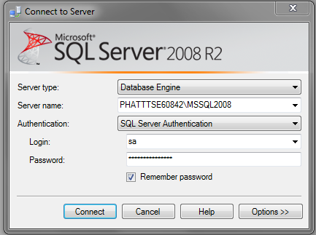

Figure 2: Deploy database – 1

* Open the script.sql file

Figure 3: Deploy database - 2

* Execute the script to finish the process

Figure 4: Deploy database - 3

#### Configure Server before deploy

* Open the Internet Information System Manager
* Change the .NET Framework version to 4.0

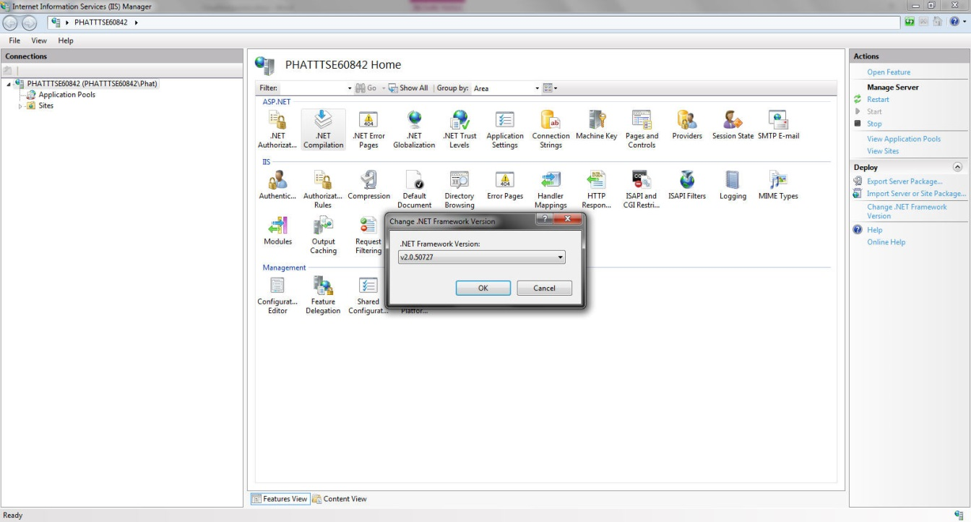

Figure 5: Configure Server before deploy – 1

* Click the Application Pool

Figure 6: Configure Server before deploy – 2

* Right click the ASP.NET 4.0 Pool, select “Advance Settings”.
* Set “Enable 32-bit Applications” to True.

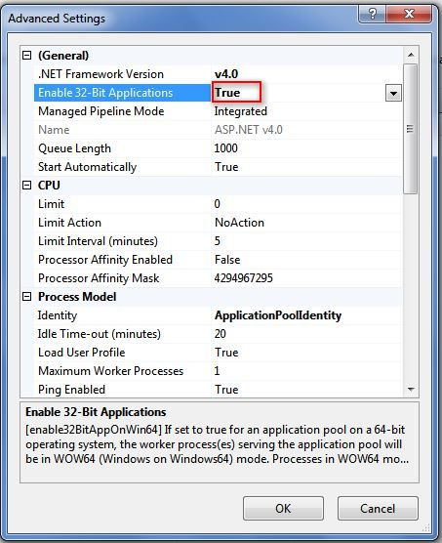

Figure 7: Configure Server before deploy - 3

#### Deploy web application on server

* Change the connection string in Web.config
* Replace the “integrated security” with your own username and password

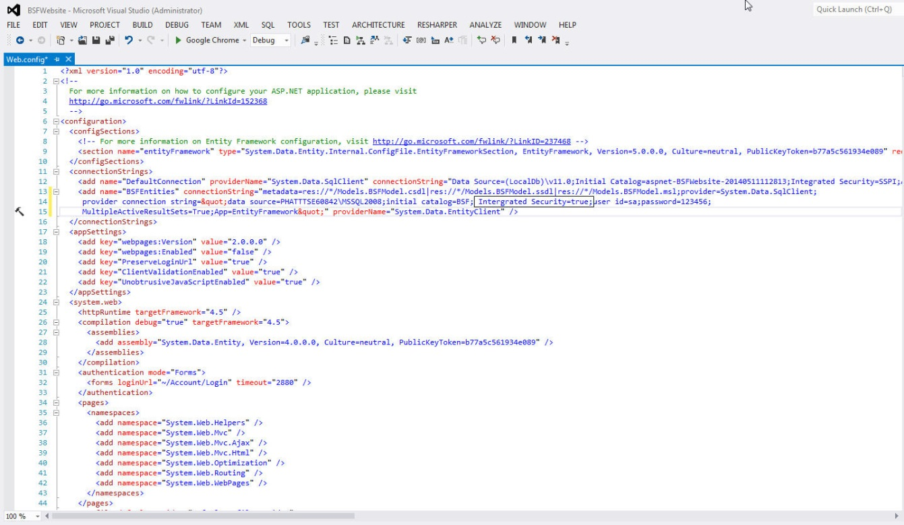

Figure 8: Deploy web application on server - 1

Figure 9: Deploy web application on server – 2

* Right click as Sites. Choose “Add Web Site”.

Figure 10: Deploy web application on server – 3

* Enter site name. Choose Application Pool as ASP.NET 4.0
* Select the path as the folder in step 1. Enter port other than 80.

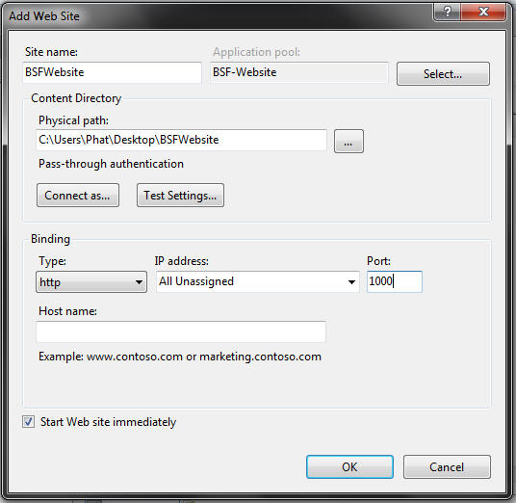

Figure 11: Deploy web application on server – 4

* Press ok to finish the process

Figure 12: Deploy web application on server – 5

## User Guide

### User – Advanced Search.

**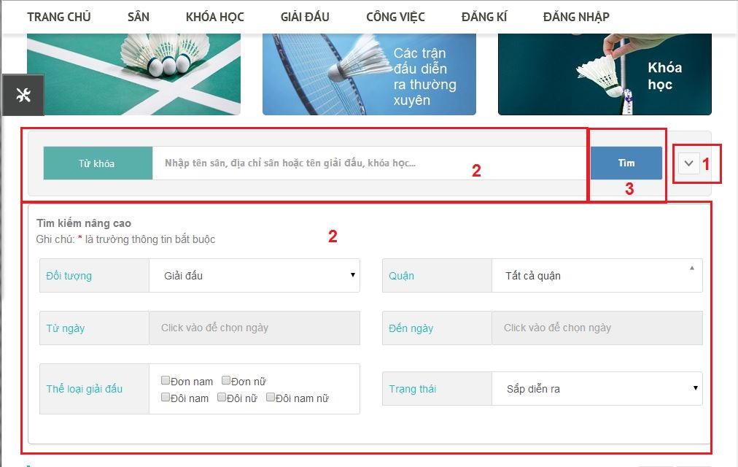**

Figure 13: Advance Search

|  |  |
| --- | --- |
| **Step** | **Description** |
| 1 | Click “Tìm kiếm nâng cao” tab button to view all search parameters. |
| 2 | Fill or choose search parameters. |
| 3 | Click “Tìm” button to search. |

Table 1:Advance Search

### User – View Upcoming Contests.

**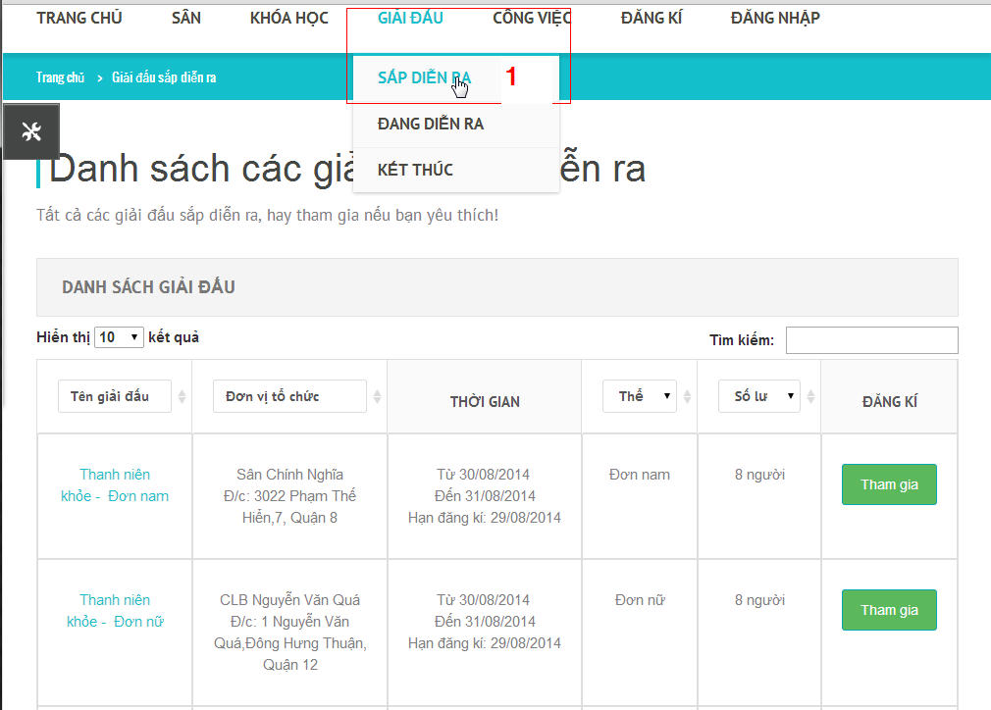**

Figure 14: View Upcoming Contests

|  |  |
| --- | --- |
| **Step** | **Description** |
| 1 | Click “Giải đâu” tab on menu, then click “Sắp diễn ra” submenu tab. |

Table 2: Upcoming Contests

### Player –Join Contest.

**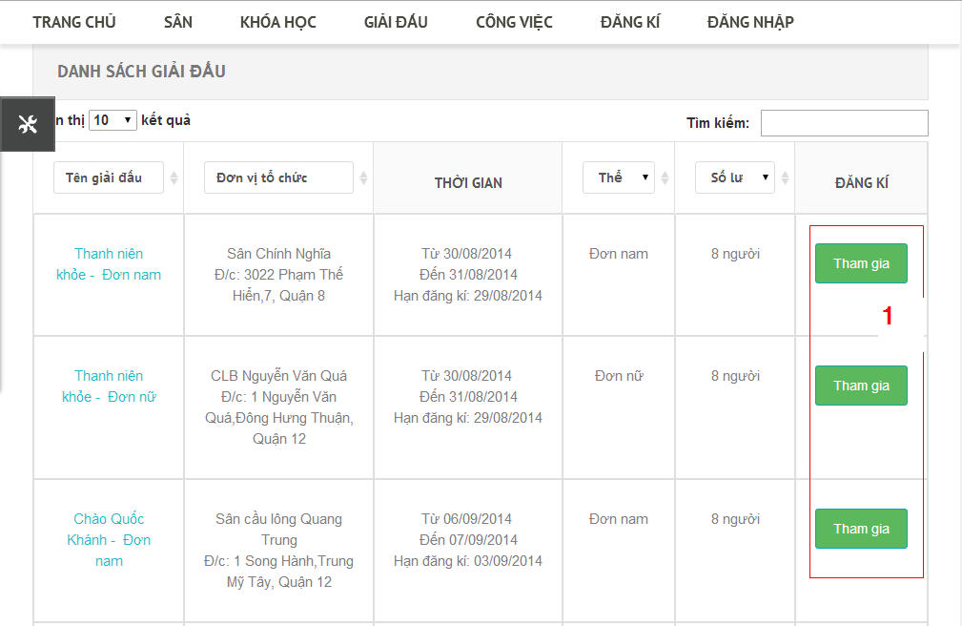**

Figure 24: Join Contest

**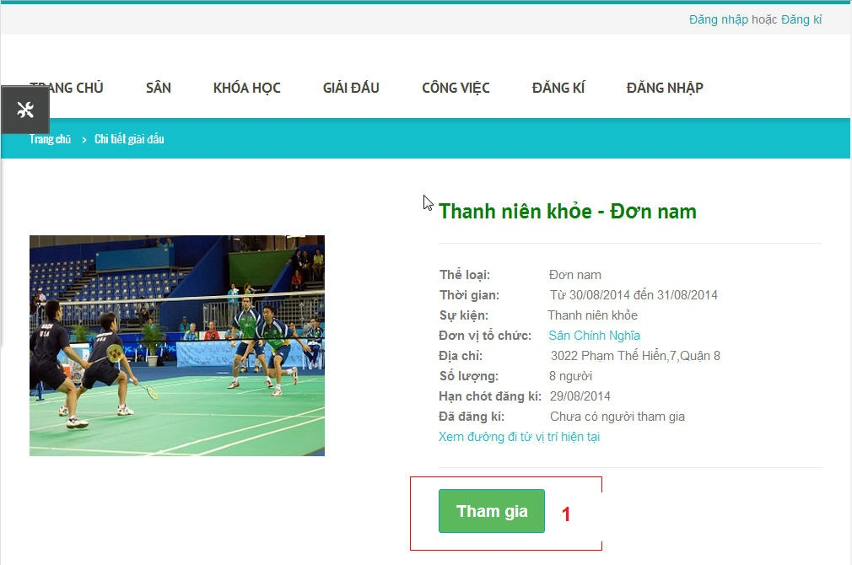**

Figure 25: Join Contest2

**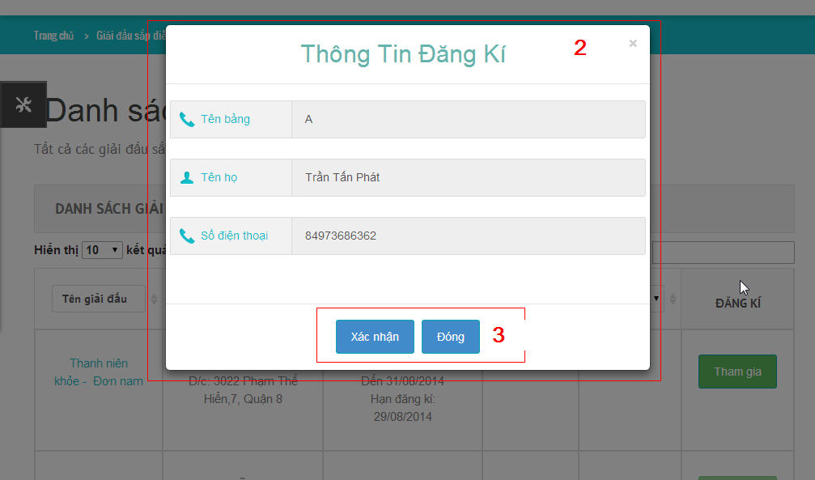**

Figure 26: Join Contest 3

|  |  |
| --- | --- |
| **Step** | **Description** |
| 1 | Click “Tham gia” button on Upcoming Contest List Table (figure) or click “Tham gia” button in Contest Detail Page. |
| 2 | System will show registration information confirm popup. |
| 3 | Click “Xác nhận” button to confirm contest joining.  Click “Đóng” button to close popup window. |

Table 8: Join contest

### User –View Contest Schedule.

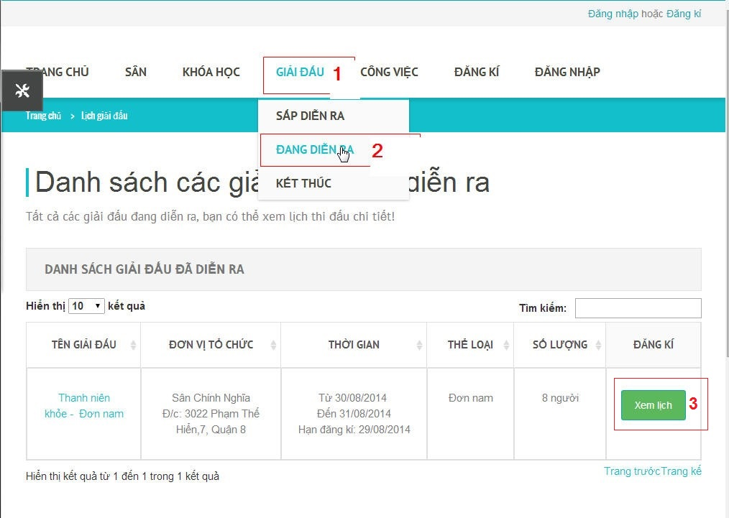

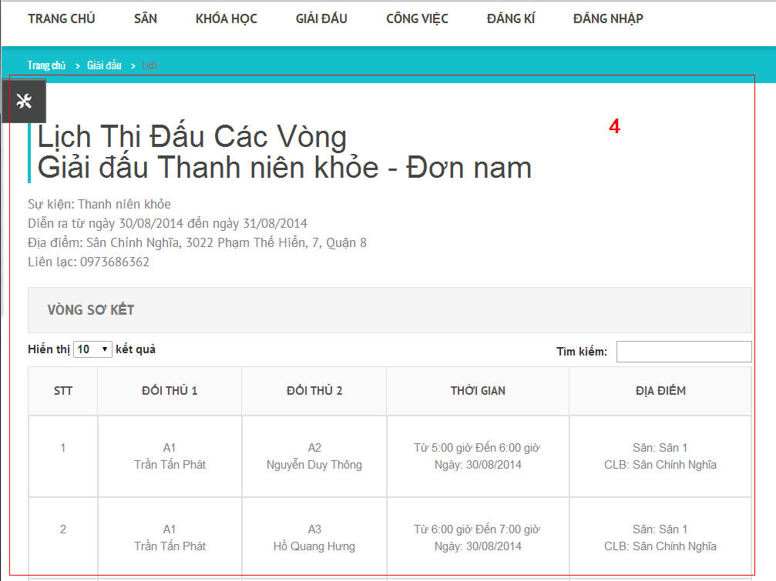

Figure 28:ViewContest Schedule

|  |  |
| --- | --- |
| **Step** | **Description** |
| 1 | Click “Giải đấu” tab on main menu. |
| 2 | System will show sub menu, choose “Đang diễn ra” submenu tab |
| 3 | Click “Xem lịch” button to view contest macth schedule. |
| 4 | System will redirect to contest match schedule page. |

Table 10: Contest Shedule

### Boss - Create Contest

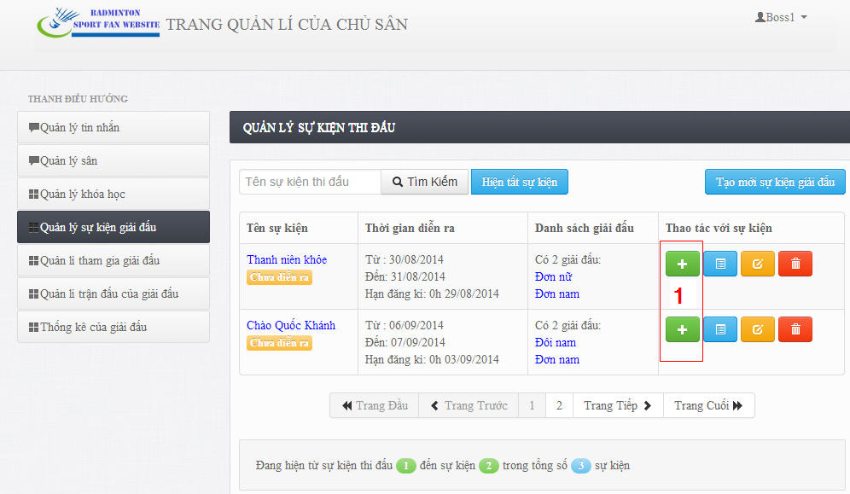

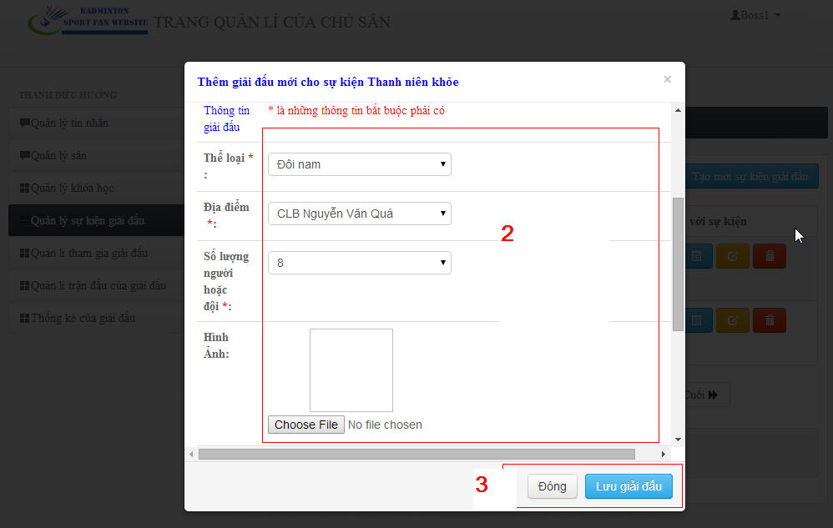

Figure 41: Create Contest Event Image

|  |  |
| --- | --- |
| **Step** | **Description** |
| 1 | Click “Tạo giải đấu” button to create new contest. |
| 2 | Fill required information of contest. |
| 3 | Click “Lưu giải đấu” button to save new contest.  Click “Đóng: button to close pop up window. |

Table 24: Create Contest

### Boss – Arrange Schedule Automatically

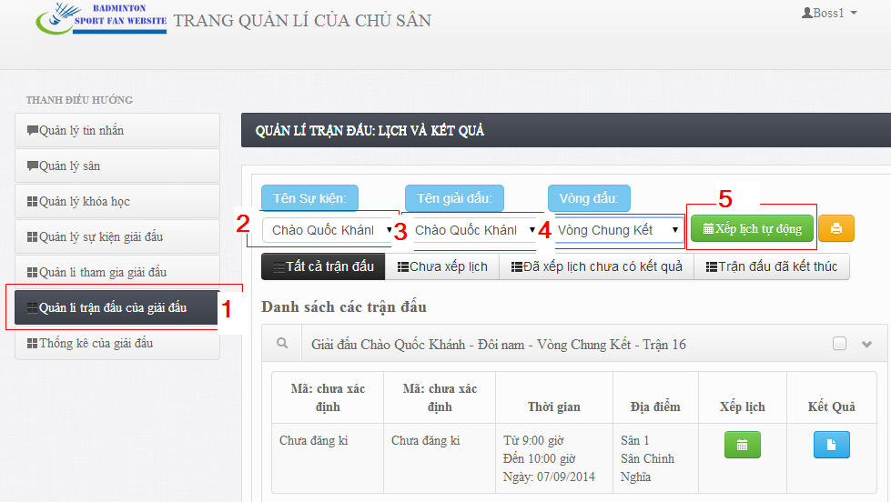

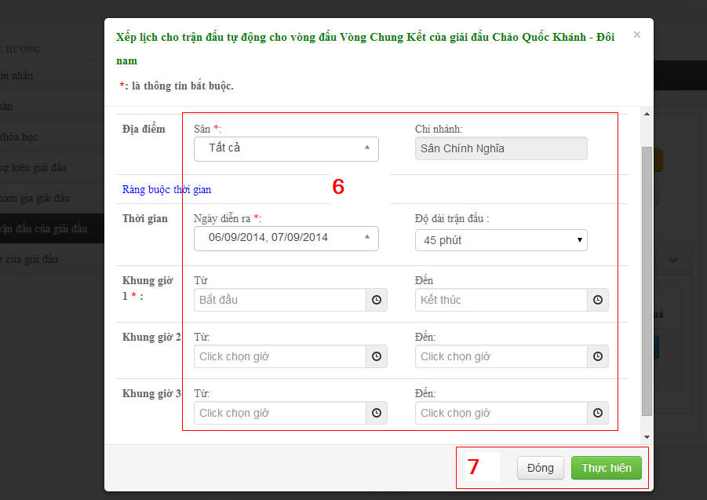

Figure 48: Edit contest event Image

|  |  |
| --- | --- |
| **Step** | **Description** |
| 1 | Click “Quản lí trận đấu của giải đấu” tab menu on navigation bar to view list of contest events. |
| 2 | Choose contest event name in contest event listbox. |
| 3 | Choose contest name in contest listbox, |
| 4 | Choose round of contest in round listbox. |
| 5 | Click “Xếp lịch tự động” button. |
| 6 | Fill required parameters. |
| 7 | Click “Thực hiện” button to arrange match schedule automatically.  Click “Đóng” button to close popup window. |

Table 31: Arrange schedule automatically

### Boss – Record Match Scores

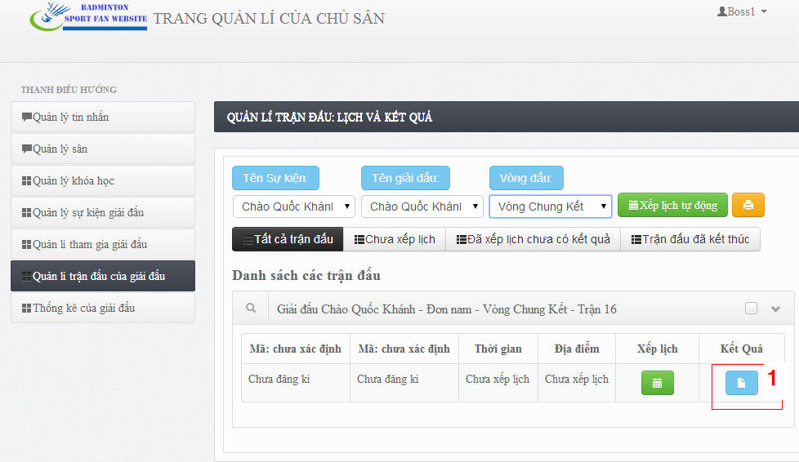

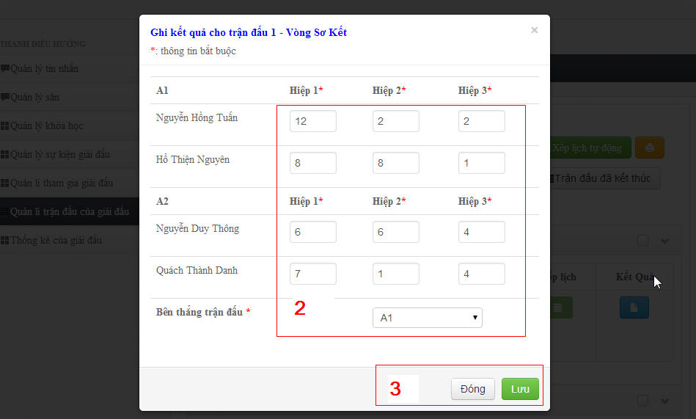

Figure 49: Delete Contest Event Image

|  |  |
| --- | --- |
| **Step** | **Description** |
| 1 | Click “Kết quả” button to record match scores and result. |
|  | Fill required information. |
| 2 | Click “Lưu” button to save information.  Click “Đóng” button to close pop up window. |

Table 32: Record Match Scores.